Martian Ripples making a Splash
Ralph D Lorenz
Johns Hopkins Applied Physics Laboratory, Laurel, MD 20723, USA.

Abstract : New work by Sullivan et al. (2020) shows that ripples of Martian sediments can have a wide range of sizes, and calls into question a proposed fluid drag mechanism and interpretations therefrom on Mars paleoclimate.
Plain Text Summary : A wide range of sizes of ripples can be formed by wind acting on sand on Earth and Mars, with the spacing controlled by the hop trajectory of individual grains. This wide range makes it problematic to use the size of ripples to deduce the density of the atmosphere in the past.

By the crisis tsunami standards of 2020, it is but a ripple. In 2011 a new text on planetary surface processes (Melosh, 2011) noted “The origin of (sand) ripples has currently reached a crisis precipitated by the observations of surface landers and rovers on Mars”. The aeolian community continues to be vexed by the challenge of these data : not a bad crisis to have, perhaps, and new paper by Sullivan et al. (2020) lays out a wide suite of observations and simulations that provide a robust challenge to a model proposed by Lapotre et al. (2016) as the crisis is, slowly, sorted out.
As creatures of a variable climate and landscape, humans have been tuned by natural selection to be drawn to irregularities in otherwise regular patterns. The endlessly similar-but-different forms of Aeolian bedforms, dunes and ripples, are therefore as beautiful to us as they are challenging to understand. For most of us, locomotion leads to a functional distinction – dunes are things to climb, whereas ripples are merely stepped on.
On Earth, the genetic distinction between ripples, whose spacings are more or less defined by the pseudoballistic individual hops (‘saltation’) of grains blown by an imposed wind, and dunes, where a growing mound influences the airflow over it and the morphology results from the feedback between the airflow and the deposition and removal of sand, is relatively clear (Bagnold, 1942). Ripples are a few centimeters to a few tens of centimeters wide, whereas dunes are several meters across to a kilometer or two. However, the diversity of conditions on other planets challenges this dichotomy (Lorenz and Zimbelman, 2014). Worlds with thicker and thinner atmospheres, different sediments and different gravity, mean that these two regimes can overlap. In particular, in the thin Martian atmosphere, it is difficult (i.e. requires faster winds) to cause grains to move, but when they do move they make much longer flights than they do on Earth. The result is that Mars can have relatively large ripples, meters to tens of meters apart. Grains there may most often be launched, not by direct pickup by the airstream (at a wind stress or speed called the ‘fluid threshold’), but rather by the collisional momentum of other grains causing ‘splash’. Once the first few pioneering grains kick off the process, sustained grain movement can happen at a different windspeed, called the ‘impact threshold’. On Titan and Venus, and underwater on Earth, the distinction is largely irrelevant as the fluid threshold is low. On Mars, however, where the thin atmosphere (50x less dense than Earth) makes the fluid threshold improbably high, the lower impact threshold offers ripples and dunes a way to form at windspeeds well below the fluid threshold (e.g. Lorenz and Zimbelman, 2014).
Dunes migrate and grow, little by little, their size and morphology being an integral property of the wind history they have endured until they reach a limiting size determined by the properties of the atmosphere (specifically, the depth of the planetary boundary layer). The shape distinction between star-shaped dunes, transverse dunes (orthogonal to the wind) and linear (longitudinal) dunes, can be mapped to the diversity of wind directions over the formation time, which for large dunes on Earth can be 50,000 years. Aeolian researchers can now reasonably confidently interpret dune morphology into characteristics of the past climate.
Most ripples on the other hand, are shaped by the individual hops made by the grains, and the wavelength of the pattern arises from the shielding of the intercrest gap from the shallow impact trajectories of grains blown in the wind. The wavelength, then, relates to the particle velocity and thus the windspeed, which varies dramatically. But since little ripples can, unlike large dunes, form and migrate on the timescale of an individual storm, they are thus much more contingent landforms – their size and shape mapping to conditions ‘when the music stopped’ (or rather, when the wind died down and grains stopped moving.) This makes ripples potentially deceiving. At one place and one time, you might have ripples of a given size as far as you can see, but they may only reflect the local conditions of the last ripple-forming windstorm, and drawing grand conclusions about paleoclimate from ripple wavelengths must be done with caution.
The gulf between dunes and ripples on Earth is considered to be bridged by a third bedform, usually referred to as megaripples. These are often characterized by a bimodal particle size, with mm-granules, or even gravel, mixed with the sand. The large grains give the system a stronger memory, their being only nudged by their more easily-blown sand fellows resulting in a very slow ‘creep’ along the surface. This memory brings additional degrees of freedom and time-dependent phenomena such as pattern-coarsening to these dynamical systems (captured nicely in sophisticated models such as that of Sullivan et al. (2020), Yizhaq et al. (2014) and Lämmel et al. (2018)). The work by Lammel et al. (2018) shows that the intermittent removal of grains is an instrumental part of the megaripple evolution process. Megaripples often have sinuous crests (see Yizhaq et al., 2014), but it is not certain if this is an exclusive property of mixed-grain-size bedforms.
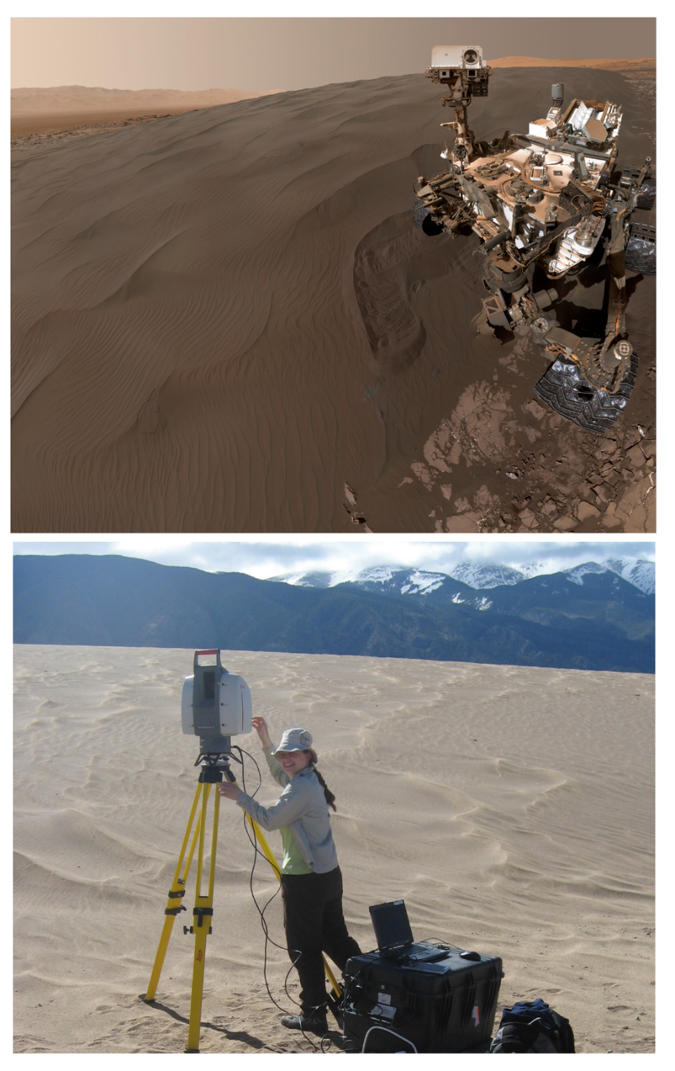
Figure 1. Different planet, same landforms under study. (top) Curiosity rover self-portrait next to the “Namib” dune in Gale Crater, Mars. Small (5-10cm) and large (~1m) ripples can be seen superposed on the dune surface. Image credit: NASA/JPL-Caltech/MSSS. (bottom) Aeolian researcher Jo Nield with a laser scanner investigating small and large ripples on a dune at Great Sand Dunes National Park and Preserve, Colorado, USA. Ripples and megaripples (not as rare on Earth as might be thought) at this site can be seen moving in timelapse action in the Supplemental Movie to this paper (see also Lorenz and Valdez, 2011). Image credit: author.

The colocation of small and large ripples superposed on a sand dune, observed up-close by the Curiosity rover (figure 1) and found to have relatively uniform grain sizes (yet with some sinuous crests), stimulated Lapotre et al. (2016) to suggest a new formation mechanism for Mars, essentially one that applies to underwater ripples on the Earth. The mechanics of how this ‘fluid-drag’ model might apply to the thin Martian atmosphere were not fully explained, but dimensionless scaling was offered to show some agreement with the observed ripple sizes. They then applied the model to deduce that the Martian atmosphere was thin when ripples formed in the long past, these being ‘fossilized’ in strata observed by an earlier rover mission.
In fact, when considering the application of their fluid drag theory to constrain past atmospheric pressure on Mars, Lapotre et al. (2016) drew upon observations by the late Nathan Bridges and myself, where we exploited the height of the colossal Tharsis volcanos on Mars to probe the effect of atmospheric density on bedform wavelength. Observations spanning 23 km of elevation and thus an order of magnitude of atmospheric density showed that (as expected from saltation hop length models applicable to the ‘classic’ ripple-sheltering mechanism) the bedform wavelength varied as the reciprocal of density. Ironically (and there is precedent in the aeolian business for using the same data, plotted different ways, to support mutually-incompatible theories as in those of ‘booming dunes’ – see Lorenz and Zimbelman, 2014) this trend seems incompatible with that predicted by the fluid drag theory (figure 2). Similarly, Sullivan et al. (2020) show that the wind speeds predicted by the fluid drag model to generate observed bedform wavelength would be too low to cause sand to actually move on Mars, so there are some quantitative difficulties with the application of the model here.
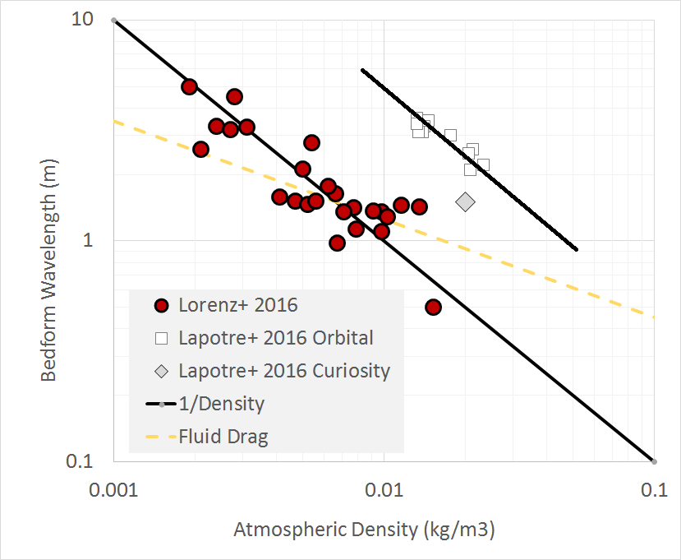
Figure 2. Bedform wavelength data and fluid drag model curve redrawn from figure S10 of Lapotre et al. (2016); their orbital data, and the orbital data used in that work from Lorenz et al. (2016), both show clearly inverse dependences on atmospheric density, a steeper variation than that predicted by the fluid drag model. The offset between the two 1/Density lines may be due to different grain sizes in the two populations of points.

Lapotre et al. (2016)’s suggestion of a fluid-drag theory was motivated by the two scales of ripples superposed on the Bagnold dunes, “in contrast to the single scale of superimposed terrestrial ripples”. Yet a wide range of superposed ripple scales are actually found on Earth too (e.g. figure 1), and Sullivan et al. (2020) also provide some examples. Furthermore, timelapse cameras (Lorenz and Valdez, 2011) let us actually see superposed patterns of straight and sinuous ripples simultaneously forming, evolving and migrating (see Supplemental Movie) so the terrestrial situation is perhaps not as simple as was stated, even without introducing additional complication of grain size diversity.
So, where do we stand ? The work of Sullivan et al. (2020) does not show that a fluid drag mechanism can never apply on Mars, only that it is not needed to explain the range of observed bedform wavelengths – the existing impact mechanism seems to provide ample diversity in this respect. Some elements of the Lapotre et al. (2016) subaqueous ripple analogy, may yet be relevant, however, in a planetary context: Vinent et al. (2019) made recent progress in mapping out the phase space of subaqueous and subaerial bedforms in simulations, and noted a scale gap due to the hydrodynamics of an internal boundary layer. Sullivan et al. (2020) similarly point to the ripple topography’s influence in sheltering the system not just from the flying grains, but from the dynamic pressure of the wind itself. These may be different facets of the same idea, and Jia et al. (2018) pointed to the boundary layer influence in an even thinner atmosphere – the transient rarified gas flows on comet 67P/Churyumov–Gerasimenko, which surprisingly also has large ripples. It seems clear that the topography-airflow interaction on ripples, ignored in the classical model, must be taken into account somehow.
How the differences (real or merely semantic) between these perspectives are resolved remains to be seen, but for now the crisis that motivated the introduction of the fluid drag model is still with us. There are quantitative challenges in reconciling the physical parameters (such as grain density) implied in orbital observations with models (Lorenz et al., 2015), and we lack the in-situ measurements of grain size or wind speed to know for sure what the conditions, let alone the process, of bedform formation was. For example, a systematic variation of windspeed with altitude for the Tharsis data might nudge the interpretation away from an exactly reciprocal density relationship. A recent paper by Silvestro et al. (2020) has measured active migration of Martian megaripples from orbit, so we at least know that the process is still active (it is striking that we now have the ability to detect geomorphogical processes on Mars that have velocities about the same as the rate of growth of our hair!) However, with only a single wind measurement station currently operating on the surface of Mars (InSight) we generally have to guess at the winds that are actually causing the motion.
Fortunately, with two more rovers (Tianwen-1 and Perseverance) on their way to Mars, and a third (Rosalind Franklin) in development, we may soon have the opportunity to investigate more ripple systems up close, and perhaps even observe them in action and document the winds that form them. On Titan, where the dense atmosphere probes a very different realm of aeolian parameter space, the Dragonfly rotorcraft lander, to land among the dunes in 2034, will not even need to wait for the rare sand-moving winds: it can use the downwash from its rotors in a controlled manner to perform in-situ saltation experiments (Lorenz et al., 2018). Perhaps, then, a century after Bagnold’s pioneering publication that has defined the field of aeolian geomorphology, we will finally understand the humble and ubiquitous ripple.

Acknowledgements
This work was supported in part by NASA Grants 80NSSC18K1626 and 80NSSC18K1389. No new data are presented in this paper.

References
Bagnold, R. A.. 1942. Physics of blown sand and desert dunes. Methuen, London, 1942.
Jia, P., Andreotti, B. and Claudin, P., 2017. Giant ripples on comet 67P/Churyumov–Gerasimenko sculpted by sunset thermal wind. Proceedings of the National Academy of Sciences, 114(10), pp.2509-2514.
Lämmel, M., Meiwald, A., Yizhaq, H., Tsoar, H., Katra, I. and Kroy, K., 2018. Aeolian sand sorting and megaripple formation. Nature Physics, 14(7), pp.759-765.
Lapotre, M.G.A., Ewing, R.C., Lamb, M.P., Fischer, W.W., Grotzinger, J.P., Rubin, D.M., Lewis, K.W., Ballard, M.J., Day, M., Gupta, S. and Banham, S.G., 2016. Large wind ripples on Mars: A record of atmospheric evolution. Science, 353(6294), pp.55-58.
Lorenz, R. D. and A. Valdez Variable Wind Ripple Migration at Great Sand Dunes National Park, Observed by Timelapse Imagery, Geomorphology, 133, 1-10, 2011
Lorenz, R. D., E. P. Turtle, J. W. Barnes, M. G. Trainer, D. S. Adams, K. E. Hibbard, C. Z. Sheldon, K. Zacny, P. N. Peplowski, D. J. Lawrence, M. A. Ravine, T. G. McGee, K. S. Sotzen, S. M. MacKenzie, J. W. Langelaan, S. Schmitz, L. S. Wolfarth, and P. Bedini. 2018. Dragonfly : A Rotorcraft Lander Concept for Scientific Exploration at Titan, Johns Hopkins Technical Digest, 34(3), 374–387
Lorenz, R.D. and Zimbelman, J.R., 2014. Dune worlds: How windblown sand shapes planetary landscapes. Springer Science & Business Media.
Melosh, H. J. 2011. Planetary Surface Processes, Cambridge University Press. Ch. 11
Silvestro, S., Chojnacki, M., Vaz, D.A., Cardinale, M., Yizhaq, H. and Esposito, F., Megaripple Migration on Mars. Journal of Geophysical Research: Planets, p.e2020JE006446.
Sullivan, R. J. F. Kok, I. Katra, H. Yizhaq, 2020. A Broad Continuum of Aeolian Impact Ripple Morphologies on Mars is Enabled by Low Wind Dynamic Pressures, Journal of Geophysical Research, in press
Vinent, O.D., Andreotti, B., Claudin, P. and Winter, C., 2019. A unified model of ripples and dunes in water and planetary environments. Nature Geoscience, 12(5), pp.345-350.
Yizhaq, H., J. F. Kok, and I. Katra (2014) Basaltic sand ripples at Eagle Crater as indirect 2254 evidence for the hysteresis effect in martian saltation, Icarus, 230, 143-150, 2255 doi:10.1016/j.icarus.2013.08.006.
Yizhaq, H., Bel, G., Silvestro, S., Elperin, T., Kok, J.F., Cardinale, M., Provenzale, A. and Katra, I., 2019. The origin of the transverse instability of aeolian megaripples. Earth and Planetary Science Letters, 512, pp.59-70.

